NOTICE OF PROPOSAL
ROAD TRAFFIC REGULATION ACT 1984
LANCASHIRE COUNTY COUNCIL
(RUNSHAW LANE, EUXTON, CHORLEY BOROUGH)
(ESTABLISHMENT OF A ZEBRA CROSSING)

NOTICE IS HEREBY GIVEN that Lancashire County Council propose to make the above Traffic Regulation Order under Section 23 of the Road Traffic Regulation Act 1984, as amended, the effect of which will be to introduce a Zebra Crossing on Runshaw Lane, Euxton, from a point 15 metres west of the Centreline of St Mary's Gate for a distance of 41 metres in a westerly direction.
Statement of Reasons
As part of highway safety improvements a zebra crossing is proposed on Runshaw Lane, west of St Mary's Gate. The effect of this will provide a crossing between the north and south side of Runshaw Lane. There is a strong demand for a controlled crossing here and this will allow for easier and safer pedestrian movements along the desire line. Tactile paving surfaces will be used as appropriate to aid the visually impaired.

A copy of the relevant notice and plan, indicating the location of the crossing may be inspected during normal office hours at the offices of the Borough Solicitor's Department
Chorley Borough Council, Town Hall, Chorley, PR7 1DP and at the offices of The Director of Governance, Finance & Public Services, Lancashire County Council, Christ Church Precinct, County Hall, Preston PR1 8XJ. Any representations or objections (specifying the grounds on which they are made) relating to the proposal must be made in writing and should be sent to The Director of Governance, Finance & Public Services, Lancashire County Council, P O Box 78, County Hall, Preston PR1 8XJ or by e-mail to tro-consultation@lancashire.gov.uk quoting ref:LSG4\894.2767\DJ before the 5th October 2016.

Ian Young, Director of Governance, Finance and Public Services
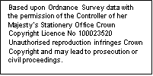
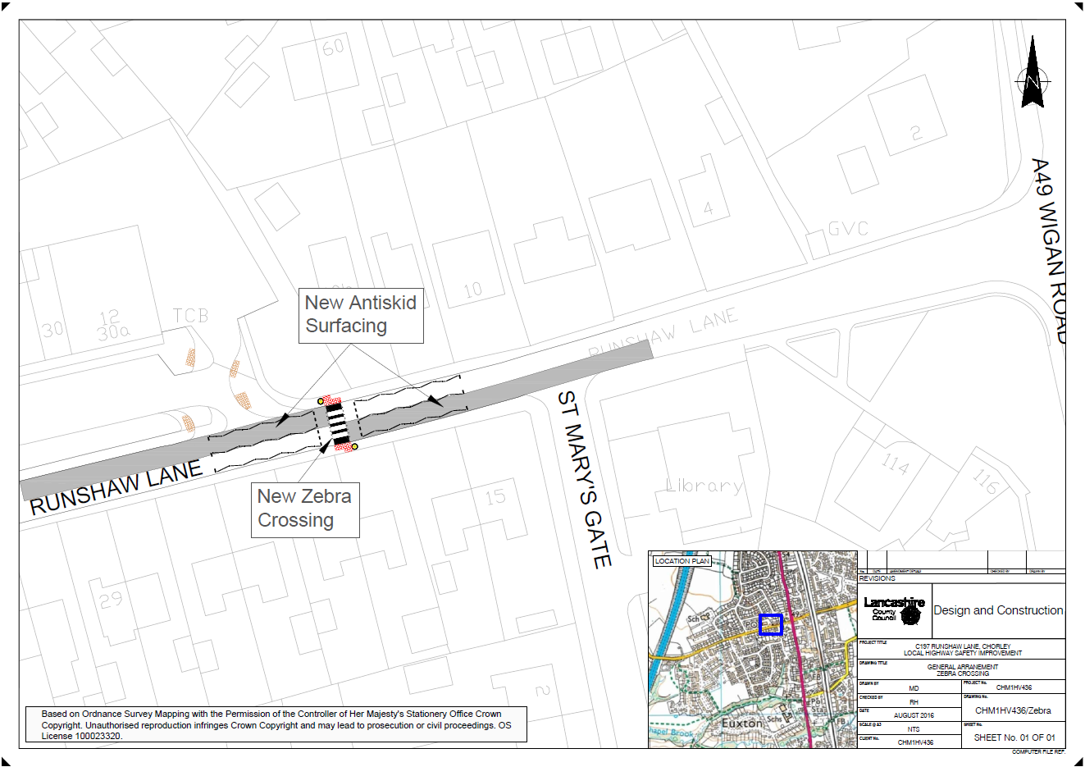
6th September 2016

